Completing An NHD Entry - Website

Project Title
Participate Name(s)
Website URL
Username |  | Password

The website category is the most interactive of all NHD categories, Therefore, a website should reflect your ability to use website design software (NHD Weebly) and computer technology to communicate the topic’s significance in history. The historical quality, analysis and interpretation of the topic must be clear and evident to the viewer through the content and navigational structure of the site.
In designing the entry, you should include elements that actively engage the audience in learning about the topic. These elements do not have to be technologically complex, but they should let the audience participate in exploring the topic, rather than passively viewing information. The presentation must include primary materials that are multimedia sources.
To produce a website, you must use weebly.com through the nhd.org portal and be able to follow the directions on it. Website entries must be published on weebly.com through the nhd.org portal. Share your finished website with at least one peer and one adult for constructive critique BEFORE submitting your entry.
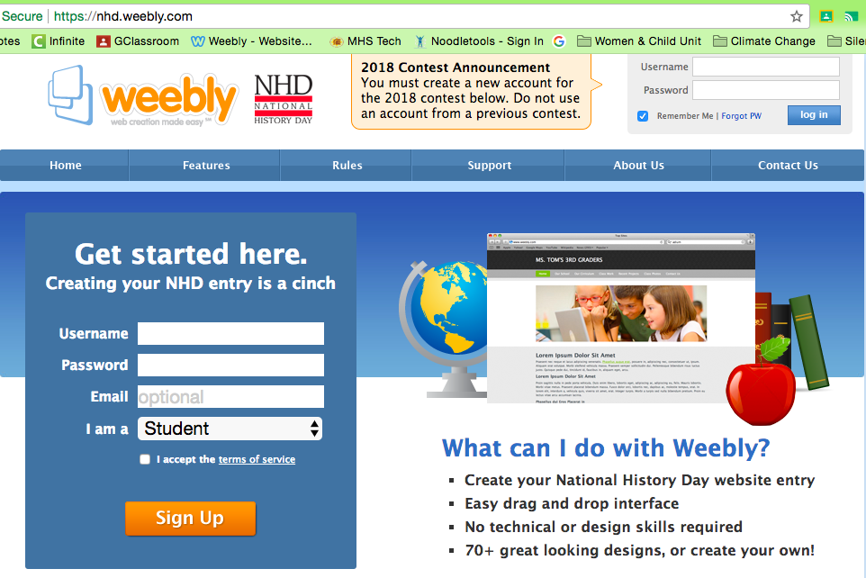

TASK TO COMPLETE FOR AN WEBSITE
Technology
 | NHD Weebly | Create a new website at https://nhd.weebly.com/ Submit the username, password, and published URL to the teacher
 | Google Folder | Create a Evidence Folder to storage visual and video files for project
 | Video Downloading & Editing | Identify online video downloading websites to save videos https://itube.aimersoft.com/download-youtube/top-website-to-download-youtube-videos.html
Analysis Statements
 | Creating Argument | Transfer key argument sentences to ‘Website Mockup Chart’ from written paper.
 | Analysis Statements Paragraphs | After teacher approval, create paragraph form analysis statements in a document. Include titles for each paragraph and format. Insert a transition word at the beginning of each point. (CHECK SPELLING AND GRAMMAR)
 | Word Limit | Check word count of analysis statements including all titles. 1200 word maximum (Timeline text counts in word count)
Evidence
 | Visual Evidence | Insert gathered primary source into ‘Website Mockup Chart.’ (Link to videos in Google Drive) Identify source archive and year. Every argument point must by supported by primary source evidence.
 | Type of Evidence | Use a variety of evidence including pictures, political cartoons, documents, etc  Avoid duplicate images and non-action photos. Quotes support visuals. Almost every content page should include a multimedia source. (4 minutes total limit)
Project Construction
 | Website Theme | Choose a theme design that highlights the topic presented with easy to navigate.
 | Home Page | The project homepage must include names of participants, entry title, division, number of student-composed words in the website, number of words in the research description, and the navigation menu.
 | Project Page Layout | Pages should have a similar layout and large headers so not distracting. Also there can be NO ACTIVE LINKS to outside pages. Recommend using only 12 pages including Home, Research Description, and Annotated Bibliography.
 | Written Evidence | Insert analysis statements to include titles on the page. Quotes are different from analysis statements and must include citations of speaker and role for each.
 | Print Visual Evidence | Each piece of evidence must include the citation of archive and year.
 | Text Color Use | Use one color for all analysis statements and another for quotes.
 | Exhibit Layout | Receive teacher approval of exhibit layout before gluing anything to the board.
Documentation
 | Website Citations |  |  | Check that all visual evidence has been cited within website
 | Research Description |  |  | Copy and paste Research Description (500 words) in own page.
 | Annotated Bibliography |  |  | Copy and paste Annotated Bibliography into own page. It needs to be alphabetized and separated into primary and secondary sources.
Project Submission
 | Publication |  | Republish website to make changes public

WEBSITE MOCKUP PLANNING CHART

WEBSITE GRAPHIC DESIGN
An website is a visual representation of your research and interpretation of your topic’s significance in history. The graphic design highlights the message of the website. The image used for graphic design and color scheme tell the story of the topic.

GRAPHIC DESIGN
Visual of Graphic Inspiration | Explanation of Graphic Design
 | Visual Image Description
 | Explain why Image Represents Topic
 | Elements Used to Replicate Image

COLOR DESIGN
Visual of Color Inspiration | Color Use Scheme
 | Background
 | Analysis Statements
 | Evidence

WEBSITE PAGE LAYOUT
Home
Thesis
Historical Context
(Triumph/Tragedy) Topic
(Triumph/Tragedy) Action/Impact 1
(Triumph/Tragedy) Action/Impact 2
(Triumph/Tragedy) Action/Impact 3
Change
Conclusion
Research Description
Annotated Bibliography

ANALYSIS STATEMENTS & EVIDENCE
The analysis of your topic must be clear to the viewer. Every point made within your analysis statements must be supported visual or quoted evidence. Use analysis statement labels to show flow of argument. Quotes should be used creatively with visual images to enhance the message of your website.

Click on the following link to go directly to the section.
TABLE OF CONTEXT
Introduction | Topic | Change 1
Thesis | Action 1 | Change 2
Historical Context | Action 2 | Change 3
 | Action 3 | Conclusion

Introduction
Time & Place Sentence
Event Description | Visual Evidence
 | Archive |  | Year
 | Link
 | Textual Evidence
 | Speaker |  | Role
 | Source

Thesis
Thesis Statement

Historical Context
Topic Sentence
Analysis: Supporting Point 1 | Visual Evidence
 | Archive |  | Year
 | Link
 | Textual Evidence
 | Speaker |  | Role
 | Source
Analysis: Supporting Point 2 | Visual Evidence
 | Archive |  | Year
 | Link
 | Textual Evidence
 | Speaker |  | Role
 | Source
Analysis: Supporting Point 3 | Visual Evidence
 | Archive |  | Year
 | Link
 | Textual Evidence
 | Speaker |  | Role
 | Source
Transition Sentence

Topic (Triumph or Tragedy)
Topic Sentence
Issue Description | Visual Evidence
 | Archive |  | Year
 | Link
 | Textual Evidence
 | Speaker |  | Role
 | Source
Event Description (5Ws) | Visual Evidence
 | Archive |  | Year
 | Link
 | Textual Evidence
 | Speaker |  | Role
 | Source
Outcome Description | Visual Evidence
 | Archive |  | Year
 | Link
 | Textual Evidence
 | Speaker |  | Role
 | Source
Transition Sentence

(Triumph or Tragedy) Action 1
Topic Sentence
Analysis: Supporting Point 1 | Visual Evidence
 | Archive |  | Year
 | Link
 | Textual Evidence
 | Speaker |  | Role
 | Source
Analysis: Supporting Point 2 | Visual Evidence
 | Archive |  | Year
 | Link
 | Textual Evidence
 | Speaker |  | Role
 | Source
Analysis: Supporting Point 3 | Visual Evidence
 | Archive |  | Year
 | Link
 | Textual Evidence
 | Speaker |  | Role
 | Source
Transition Sentence

(Triumph or Tragedy) Action 2
Topic Sentence
Analysis: Supporting Point 1 | Visual Evidence
 | Archive |  | Year
 | Link
 | Textual Evidence
 | Speaker |  | Role
 | Source
Analysis: Supporting Point 2 | Visual Evidence
 | Archive |  | Year
 | Link
 | Textual Evidence
 | Speaker |  | Role
 | Source
Analysis: Supporting Point 3 | Visual Evidence
 | Archive |  | Year
 | Link
 | Textual Evidence
 | Speaker |  | Role
 | Source
Transition Sentence

(Triumph or Tragedy) Action 3
Topic Sentence
Analysis: Supporting Point 1 | Visual Evidence
 | Archive |  | Year
 | Link
 | Textual Evidence
 | Speaker |  | Role
 | Source
Analysis: Supporting Point 2 | Visual Evidence
 | Archive |  | Year
 | Link
 | Textual Evidence
 | Speaker |  | Role
 | Source
Analysis: Supporting Point 3 | Visual Evidence
 | Archive |  | Year
 | Link
 | Textual Evidence
 | Speaker |  | Role
 | Source
Transition Sentence

(SPICE Type) Change 1
Topic Sentence
Analysis: Supporting Point 1 | Visual Evidence
 | Archive |  | Year
 | Link
 | Textual Evidence
 | Speaker |  | Role
 | Source
Analysis: Supporting Point 2 | Visual Evidence
 | Archive |  | Year
 | Link
 | Textual Evidence
 | Speaker |  | Role
 | Source

(SPICE Type) Change 2
Topic Sentence
Analysis: Supporting Point 1 | Visual Evidence
 | Archive |  | Year
 | Link
 | Textual Evidence
 | Speaker |  | Role
 | Source
Analysis: Supporting Point 2 | Visual Evidence
 | Archive |  | Year
 | Link
 | Textual Evidence
 | Speaker |  | Role
 | Source

(SPICE Type) Change 3
Topic Sentence
Analysis: Supporting Point 1 | Visual Evidence
 | Archive |  | Year
 | Link
 | Textual Evidence
 | Speaker |  | Role
 | Source
Analysis: Supporting Point 2 | Visual Evidence
 | Archive |  | Year
 | Link
 | Textual Evidence
 | Speaker |  | Role
 | Source

Conclusion
Summary Sentence | Visual Evidence
 | Archive |  | Year
 | Link
 | Textual Evidence
 | Speaker |  | Role
 | Source
Thesis Reworded
Opinion of Significance

