Completing An NHD Entry - Performance

Project Title
Participate Name(s)

The idea of living history, or using performance to preserve and explain the past, is as old as history itself. While such performances must have dramatic appeal, this must not be at the expense of historical information. Do good research FIRST – don’t jump right in and start writing a script. When you do write a script, make sure it contains references to the historical evidence you found in your research. Using actual dialogue, quotations or taking excerpts from speeches or oral histories are good ways of putting historical detail into your performance. Become the historical figure and write your script around an important time or place which will explain your research. Remember that your performance must reflect your thesis statement, supporting ideas and conclusion and must be RELEVANT TO THE THEME!
Performances are dramas depicting an event, person, or place. These dramas are written, directed and acted by the group members (no more than three) or individual performer. They may be up to ten minutes long, with five minutes allowed to set up and five minutes to tear down. Scenery and props may be used, with lighting or sound effects, but students in the group must run all equipment. Good costumes are appropriate to the topic and historically accurate.
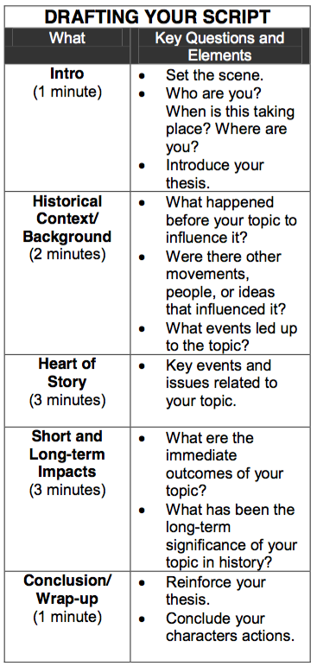
You are in the only “live” category of History Day but for the school-level, your Performance will be recorded on video. Be sure you have communicated your thesis and its relation to the theme overtly. At every step of the way, ask other people’s advice. This is especially true when you have finished the script and are in rehearsal. Practice! Practice! Practice!
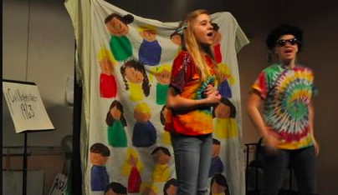

TASK TO COMPLETE FOR AN PERFORMANCE
Script Foundation
 | (Scenario) Storyline | Provide a summary of the scenario and storyline the performance will follow.
 | Setting | Describe the setting on the overall performance and individual scenes.
 | Scenes | Identify the various scenes (Introduction & Thesis, Historical Context, Topic & Actions, Change, and Conclusion)
 | Characters | List the main character and composite characters
Background & Props
 | Backdrop | Secure use of a performance curtain frame to create backdrop
 | Props | List a list of props needed to stage the performance such chairs, table, podium.
 | Audio Visual | Determine if sound or visual equipment will be required.
Argument and Factual Evidence
 | Argument | In the purpose of the scene, identify the argument being presented.
 | Factual Evidence | In the identify columns, identify the main points and factual evidence being addressed in the dialog.
Written Script
 | Dialog | Use the identified argument and facts, create the dialog the different characters will use in each scene. Script can not exceed 10 minutes
 | Movement | Provide informative on movement on the stage such as entrance and exit.
 | Script Approval | Conference with the teacher to receive approval of finalized script.
Blocking
 | Blocking |  |  | Work with teacher to plan standing position and movement on the stage.
 | Memorization |  |  | After movement has been planned, memorize the approved script.
Documentation
 | Research Description |  |  | Type the 500 word Research Description and share file with teacher
 | Annotated Bibliography |  |  | Create a file of the Annotated Bibliography. It needs to be alphabetized and separated into primary and secondary sources. Share with teacher.
Project Submission
 | Schedule Recording |  | See teacher to arrange and recording date and time.
 | Performance |  | Record performance at the appointed time.

PERFORMANCE PLANNING CHART

The performance category can be one of the most exciting ways to participate in History Day, since it is the only category in which students present their research live. Entries in this category must have dramatic appeal, but not at the expense of historical information. Creativity is the key here, and students must make effective use of their 10-minute time allowance.

PERFORMANCE OVERALL SCENARIO
Summarize the Story | Key Elements
 | Setting
 | Timeframe
 | Characters

CHARACTER DEVELOPMENT
Name | Provide a description/background for the character and purpose.

COSTUMES & PROPS
Describe the Stage(s) of the Performance | Color Use Scheme
 | Background
 | Costume
 | Props
 | Audio Visual

PERFORMANCE SCRIPT

SCENE 1 - SCENARIO
Purpose of the Scene | Key Elements
 | Setting
 | Timeframe
 | Characters
Summary the Scene (5Ws)

DIALOG - SCENE 1
Character | Dialog | Argument/Factual Evidence

SCENE 2 - SCENARIO
Purpose of the Scene | Key Elements
 | Setting
 | Timeframe
 | Characters
Summary the Scene (5Ws)

DIALOG - SCENE 2
Character | Dialog | Argument/Factual Evidence

SCENE 3 - SCENARIO
Purpose of the Scene | Key Elements
 | Setting
 | Timeframe
 | Characters
Summary the Scene (5Ws)

DIALOG - SCENE 3
Character | Dialog | Argument/Factual Evidence

SCENE 4 - SCENARIO
Purpose of the Scene | Key Elements
 | Setting
 | Timeframe
 | Characters
Summary the Scene (5Ws)

DIALOG - SCENE 4
Character | Dialog | Argument/Factual Evidence

SCENE 5 - SCENARIO
Purpose of the Scene | Key Elements
 | Setting
 | Timeframe
 | Characters
Summary the Scene (5Ws)

DIALOG - SCENE 5
Character | Dialog | Argument/Factual Evidence

