Completing An NHD Entry - Exhibit

Project Title
Participate Name(s)

An exhibit is a visual representation of your research and interpretation of your topic’s significance in history. The graphic design highlights the message of the exhibit. The image used for graphic design and color scheme tell the story of the topic.
Emphasis in scoring a History Day entry is placed on historical quality, but the quality of presentation is also important (especially choices regarding the flow of information and visual development of ideas). Part of the job of any historian is to communicate his or her research to others. How can you best SHOW your thesis and findings to an audience? Remember, most people at a History Day event will be viewing your exhibit for the first time. Will they understand what it is all about? Will they understand the focus and the conclusion of your research? Your exhibit should stand on its own in an eye-catching, stimulating yet informative presentation.
An exhibit project includes the exhibit itself, a summary of the thesis and research process (up to 500 words) and the bibliography. The exhibit component must include the display and title board with charts or maps. For school-level competition, the overall size of the exhibit must be 24” wide for the center back panel, 12” wide for each of the side panels, and 36” high. Exhibits should have a title clearly displayed, sections labeled and in a sequence that is easy to understand, and captions under all pictures or visuals—all of which must not exceed 500 student-composed words. Captions with quotes must be footnoted and artifacts identified. It is best to make a scale model of the display before beginning construction. Wired lights, artifacts on the tabletop, chicken wire or other such items are strongly discouraged at the school level to avoid theft or injury.
Before you finalize your project have at least one peer and one adult look at it. Listen to their comments on the clarity of the presentation, impact on the viewer and historical quality. Does the point you are trying to make come across? Changes can and should be made if any of these items are reacted to negatively.
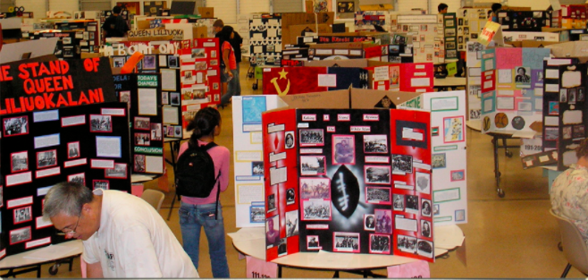

TASK TO COMPLETE FOR AN EXHIBIT
Materials
 | Board Size | Project board height must be 36 inches (3 feet). No taller, no shorter
 | Construction Supplies | Obtain 2 color backing paper for text and evidence, rubber cement, and paint for board background design
 | Graphic Design | Complete ‘Exhibit Graphic Design’ and seek approval from teacher
Analysis Statements
 | Creating Argument | Transfer key argument sentences to ‘Exhibit Mockup Chart’ from written paper.
 | Analysis Statements Paragraphs | After teacher approval, create paragraph form analysis statements in a document. Include titles for each paragraph and format. Insert a transition word at the beginning of each point. (CHECK SPELLING AND GRAMMAR)
 | Text Format | Use Arial 18 point font, .5 margin on all sides, 1.5 spacing
 | Word Limit | Check word count of analysis statements including all titles. 600 word maximum (Timeline text counts in word count)
Evidence
 | Visual Evidence | Insert gathered primary source into ‘Exhibit Mockup Chart.’ Identify source archive and year. Every argument point must by supported by evidence
 | Type of Evidence | Use a variety of evidence including pictures, political cartoons, documents, etc  Avoid duplicate images and non-action photos. Quotes support visuals
Project Construction
 | Background Design | Complete background design with color, point, drawing, or collage
 | Print Written Evidence | Print analysis statements to include titles as part of text block. Print quotes the same size as analysis statements. Include citation of speaker and role
 | Print Visual Evidence | Resize and print images to no smaller than 3x5 or larger than 4x6. Each piece of evidence must include the citation of archive and year.
 | Project Title | Receive teacher approval for title placement, size, and materials used to display
 | Color Backing | Mount all analysis statements on one color. Mount all evidence on another color. Use only 2 colors
 | Exhibit Layout | Receive teacher approval of exhibit layout before gluing anything to the board.
Documentation
 | On Board Citations |  |  | Check that all visual evidence has been cited on exhibit
 | Research Description |  |  | Write and type Research Description (500 words) and title page. Print 2 copies
 | Annotated Bibliography |  |  | Print 2 copies of the Annotated Bibliography. Alphabetize and separate into primary and secondary sources.
Project Submission
 | Entry Number & Label |  | See teacher for project Identification Label and Entry Number labels
 | Project Paperwork |  | Attach 1 copy of Title Page, Research Description, and Annotated Bibliography

EXHIBIT MOCKUP PLANNING CHART

EXHIBIT GRAPHIC DESIGN
An exhibit is a visual representation of your research and interpretation of your topic’s significance in history. The graphic design highlights the message of the exhibit. The image used for graphic design and color scheme tell the story of the topic.

GRAPHIC DESIGN
Visual of Graphic Inspiration | Explanation of Graphic Design
 | Visual Image Description
 | Explain why Image Represents Topic
 | Elements Used to Replicate Image

COLOR DESIGN
Visual of Color Inspiration | Color Use Scheme
 | Background
 | Analysis Statements
 | Evidence

EXHIBIT LAYOUT
PANEL 1 | PANEL 2 | PANEL 3
Introduction | Topic | Change 1
Thesis | Action/Impact 1 | Change 2
Historical Context | Action/Impact 2 | Change 3
 | Action/Impact 3 | Conclusion

ANALYSIS STATEMENTS & EVIDENCE
The analysis of your topic must be clear to the viewer. Every point made within your analysis statements must be supported visual or quoted evidence. Use analysis statement labels to show flow of argument. Quotes should be used creatively with visual images to enhance the message of your exhibit. Click on the following link to go directly to the section.
TABLE OF CONTEXT
Introduction | Topic | Change 1
Thesis | Action/Impact 1 | Change 2
Historical Context | Action/Impact 2 | Change 3
 | Action/Impact 3 | Conclusion

Requirements Explained and Sample
Topic Sentence | Sentence summarizing the overall cause of the issue
Analysis: Supporting Point 1 | Visual Evidence
(Begin with transition word)  One sentence identifying a cause of the issue | Action image showing evidence of statement
 | Archive | Location of stored evidence | Year | Year produced
 | Link | URL link to location of evidence
 | Textual Evidence
 | Direct quote showing evidence of statement
 | Speaker | Who said it or wrote it | Role | Relationship to topic
 | Source | What is the name of the document, speech, newspaper, etc.
Analysis: Supporting Point 2 | Visual Evidence
After the Civil War, racial segregation laws , known as Jim Crow laws, also continued to divide southern society. | 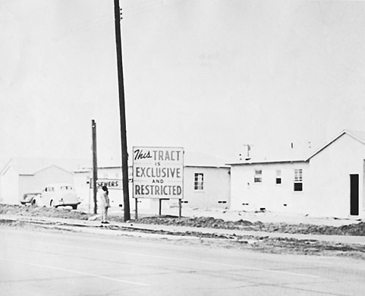
 | Archive | Southern California Library for Social Studies and Research | Year | 1950
 | Link | http://americanhistory.si.edu/brown/history/1-segregated/jim-crow.html
 | Textual Evidence
 | “All railroads carrying passengers in the state (other than street railroads) shall provide equal but separate accommodations for the white and colored races, by providing two or more passenger cars for each passenger train, or by dividing the cars by a partition, so as to secure separate accommodations.”
 | Speaker | Tennessee | Role | Jim Crow Law 1891
 | Source | http://www.americanhistory.si.edu/brown/history/1-segregated/detail/jim-crow-laws.html

Introduction
Time & Place Sentence
Event Description | Visual Evidence
 | Archive |  | Year
 | Link
 | Textual Evidence
 | Speaker |  | Role
 | Source

Thesis
Thesis Statement

Historical Context
Topic Sentence
Analysis: Supporting Point 1 | Visual Evidence
 | Archive |  | Year
 | Link
 | Textual Evidence
 | Speaker |  | Role
 | Source
Analysis: Supporting Point 2 | Visual Evidence
 | Archive |  | Year
 | Link
 | Textual Evidence
 | Speaker |  | Role
 | Source
Analysis: Supporting Point 3 | Visual Evidence
 | Archive |  | Year
 | Link
 | Textual Evidence
 | Speaker |  | Role
 | Source
Transition Sentence

Topic (Conflict or Compromise)
Topic Sentence
Issue Description | Visual Evidence
 | Archive |  | Year
 | Link
 | Textual Evidence
 | Speaker |  | Role
 | Source
Event Description (5Ws) | Visual Evidence
 | Archive |  | Year
 | Link
 | Textual Evidence
 | Speaker |  | Role
 | Source
Outcome Description | Visual Evidence
 | Archive |  | Year
 | Link
 | Textual Evidence
 | Speaker |  | Role
 | Source
Transition Sentence

(Conflict or Compromise) Action 1
Topic Sentence
Analysis: Supporting Point 1 | Visual Evidence
 | Archive |  | Year
 | Link
 | Textual Evidence
 | Speaker |  | Role
 | Source
Analysis: Supporting Point 2 | Visual Evidence
 | Archive |  | Year
 | Link
 | Textual Evidence
 | Speaker |  | Role
 | Source
Analysis: Supporting Point 3 | Visual Evidence
 | Archive |  | Year
 | Link
 | Textual Evidence
 | Speaker |  | Role
 | Source
Transition Sentence

(Conflict or Compromise) Action 2
Topic Sentence
Analysis: Supporting Point 1 | Visual Evidence
 | Archive |  | Year
 | Link
 | Textual Evidence
 | Speaker |  | Role
 | Source
Analysis: Supporting Point 2 | Visual Evidence
 | Archive |  | Year
 | Link
 | Textual Evidence
 | Speaker |  | Role
 | Source
Analysis: Supporting Point 3 | Visual Evidence
 | Archive |  | Year
 | Link
 | Textual Evidence
 | Speaker |  | Role
 | Source
Transition Sentence

(Conflict or Compromise) Action 3
Topic Sentence
Analysis: Supporting Point 1 | Visual Evidence
 | Archive |  | Year
 | Link
 | Textual Evidence
 | Speaker |  | Role
 | Source
Analysis: Supporting Point 2 | Visual Evidence
 | Archive |  | Year
 | Link
 | Textual Evidence
 | Speaker |  | Role
 | Source
Analysis: Supporting Point 3 | Visual Evidence
 | Archive |  | Year
 | Link
 | Textual Evidence
 | Speaker |  | Role
 | Source
Transition Sentence

(SPICE Type) Change 1
Topic Sentence
Analysis: Supporting Point 1 | Visual Evidence
 | Archive |  | Year
 | Link
 | Textual Evidence
 | Speaker |  | Role
 | Source
Analysis: Supporting Point 2 | Visual Evidence
 | Archive |  | Year
 | Link
 | Textual Evidence
 | Speaker |  | Role
 | Source

(SPICE Type) Change 2
Topic Sentence
Analysis: Supporting Point 1 | Visual Evidence
 | Archive |  | Year
 | Link
 | Textual Evidence
 | Speaker |  | Role
 | Source
Analysis: Supporting Point 2 | Visual Evidence
 | Archive |  | Year
 | Link
 | Textual Evidence
 | Speaker |  | Role
 | Source

(SPICE Type) Change 3
Topic Sentence
Analysis: Supporting Point 1 | Visual Evidence
 | Archive |  | Year
 | Link
 | Textual Evidence
 | Speaker |  | Role
 | Source
Analysis: Supporting Point 2 | Visual Evidence
 | Archive |  | Year
 | Link
 | Textual Evidence
 | Speaker |  | Role
 | Source

Conclusion
Summary Sentence | Visual Evidence
 | Archive |  | Year
 | Link
 | Textual Evidence
 | Speaker |  | Role
 | Source
Thesis Reworded
Opinion of Significance

