Completing An NHD Entry - Documentary

Project Title
Participate Name(s)
Video URL
Research Description URL
Annotated Bibliography URL

A documentary media presentation can be an exciting way of sharing historical research. In choosing a topic, it is important that the subject fits the History Day theme and the documentary format fits the topic. Remember, this is a history event, not a film festival. The quality of the historical research is the essence of the presentation. Your thesis and its supporting evidence must be communicated to your audience.
Storyboarding is an important part of the documentary process. This technique is used to help you decide which pictures, graphics and sound will best suit the narrative script. When you have done your research and written a good script, divide the script into segments with appropriate visuals and video clips shown or drawn in. At this point, the visuals and narrative must match up and communicate the basic message of your project – including a clear statement of your thesis, a coherent documentation of supporting evidence (historical information and interpretation), and a conclusion that points out the historical significance of your program.
Documentary media entries must be shared in MP4 format and must be accompanied by a digital copy of the Research Description and Annotated Bibliography. Your file be tested on multiple computers before submission.
Documentaries should be no shorter than 7 minutes and no longer than 10 minutes. Share your finished documentary with at least one peer and one adult for constructive critique BEFORE submitting your entry.
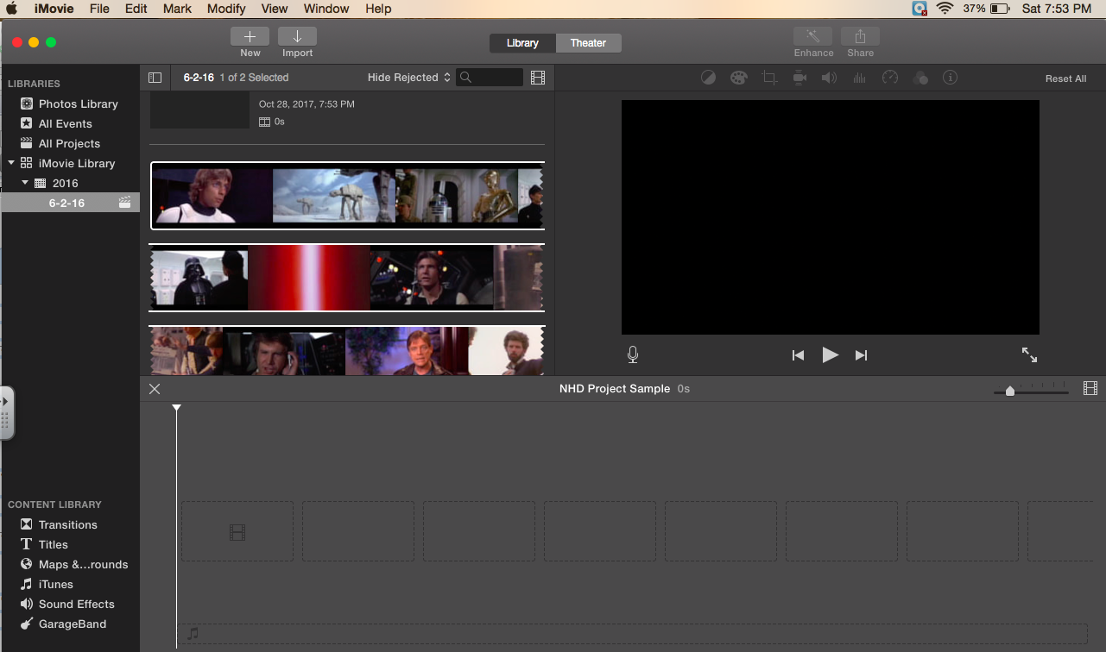
TASK TO COMPLETE FOR AN DOCUMENTARY
Technology
 | Video Editor | Identify program and computer to use for video creation.
 | Google Folder | Create a Evidence Folder to storage visual and video files for project
 | Video Downloading & Editing | Identify online video downloading websites to save videos https://itube.aimersoft.com/download-youtube/top-website-to-download-youtube-videos.html  Video clip editor: http://online-video-cutter.com/
Narration (Script Storyboard)
 | Finalize Script | Transfer key argument sentences to ‘Website Mockup Chart’ from written paper.
 | Storyboard Narration | After teacher approval, Transfer key argument sentences to ‘Website Mockup Chart’ from written paper. One sentence per slot. (CHECK GRAMMAR)
 | Time Limit | Check read narration is no longer than 10 minutes. (No shorter than 7 minutes)
 | Background Music | Any music use must be relative to the subject. Instrumental preferred.
Visual Evidence (Storyboard)
 | Visual Evidence | Insert gathered primary source into ‘Storyboard’ (Link to videos in Google Drive) Every sentence of narration must match a unique primary source visual. Number image files in Google folder for easy assembly during production.
 | Interview | Attempt to include multiple interviews highlighting argument. It can be a personal interview conducted or from another source.
Project Construction
 | Narration | Record narration by paragraph segments and insert into audio section. Narration must be done by students of project.
 | Visual Evidence | Insert images in order and adjust time to match length of sentence. Take transitions into account for timing.
 | Titles | Project title should be visible before thesis. Section titles are optional.
 | Transitions | Transitions should remain simple and non-distracting.
 | Music | Adjust music volume to not overpower narration.
Documentation
 | Video Credits |  |  | Check that all visual evidence has been cited within video if need (copyright items such as motion pictures)
 | Interview Credits |  |  | For each interview, provide information as onscreen text to include speaker name, role of speaker, and source.
 | End Credits |  |  | At the conclusion of the documentary, you must provide a list of acknowledgments and credits for sources such as music, images, film/media clips, and interviews. These credits should be brief—not full bibliographic citations and not annotated. Credits count in 10 minutes.
 | Research Description |  |  | Share with teacher the Research Description (500 words) file.
 | Annotated Bibliography |  |  | Share with teacher the Annotated Bibliography file It needs to be alphabetized and separated into primary and secondary sources.
Project Submission
 | Google Drive |  | Upload video in .MP4 format and share with teacher.
DOCUMENTARY PLANNING CHARTS

INTERVIEWS
Interview #1 | Evidence Provided by Interview
Who and why?

 | On Screen Text for Documentary
 | Speaker |  | Role
 | Source
Interview #2 | Evidence Provided by Interview
 | On Screen Text for Documentary
 | Speaker |  | Role
 | Source
Interview #3 | Evidence Provided by Interview
 | On Screen Text for Documentary
 | Speaker |  | Role
 | Source

MUSICAL TRACKS
Track # | Title | Artist
Track 1
Track 2
Track 3

DOCUMENTARY STORYBOARD

Click on the following link to go directly to the section.
TABLE OF CONTEXT
Introduction & Thesis | Action 1 | Change 1
Historical Context | Action 2 | Change 2
Topic | Action 3 | Change 3
 |  | Conclusion

Introduction & Thesis
# | Narration | Visual | Source Link
1
2
3
4
5
6
7
8

Historical Context
# | Narration | Visual | Source Link
1
2
3
4
5
6
7
8

(Triumph or Tragedy) Topic
# | Narration | Visual | Source Link
1
2
3
4
5
6
7
8

(Triumph/Tragedy) Action or Impact 1
# | Narration | Visual | Source Link
1
2
3
4
5
6
7
8
9
10
11
12

(Triumph/Tragedy) Action or Impact 2
# | Narration | Visual | Source Link
1
2
3
4
5
6
7
8
9
10
11
12

(Triumph/Tragedy) Action or Impact 3
# | Narration | Visual | Source Link
1
2
3
4
5
6
7
8
9
10
11
12

Change 1
# | Narration | Visual | Source Link
1
2
3
4
5

Change 2
# | Narration | Visual | Source Link
1
2
3
4
5

Change 3
# | Narration | Visual | Source Link
1
2
3
4
5

Conclusion
# | Narration | Visual | Source Link
1
2
3
4
5
6
7
8

